Secure communication over the internet is typically achieved using HTTPS for web applications and SSL/TLS for other protocols, including TCP-based communication. Here's a detailed explanation:

1. What is HTTPS?
HTTPS (Hypertext Transfer Protocol Secure) is the secure version of HTTP, achieved by encrypting data using SSL/TLS (Secure Sockets Layer/Transport Layer Security).
- Encryption: Protects data from being intercepted (man-in-the-middle attacks).
- Authentication: Verifies the server's identity using SSL/TLS certificates.
- Integrity: Ensures data is not altered during transmission.

2. SSL Certificates
An SSL certificate is a digital certificate that binds a public key with an entity’s identity (e.g., a domain name or company name). These certificates are essential for establishing secure communication channels.

Key Properties of SSL Certificates:
- Issued By: Certificate Authorities (CAs), such as Let's Encrypt or DigiCert.
- Contains:
  - Public key
  - Domain name
  - Organization details
  - Certificate validity period
  - Digital signature of the CA

How SSL Works:
- Handshake:
  - Client verifies the server's certificate.
  - Server sends its public key.
  - Session keys are exchanged securely.
- Secure Communication:
  - Data is encrypted using session keys.

3. SSL/TLS for TCP
While HTTPS secures HTTP traffic, SSL/TLS can secure any protocol over TCP, such as custom application protocols.

Use Cases:
- Custom TCP Protocols:
  - Applications using TCP for communication can secure data using SSL/TLS (e.g., database protocols like MySQL or messaging systems like MQTT).
- gRPC:
  - Uses HTTP/2 and supports TLS for secure communication.
- FTP over TLS (FTPS):
  - Secures file transfers.

4. Steps to Set Up SSL/TLS for TCP Applications

4.1 Obtain an SSL Certificate
- Self-Signed Certificate:
  - Used for internal or testing purposes.
  - Example command with OpenSSL:
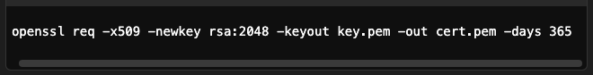
- CA-Signed Certificate:
  - Trusted by clients.
  - Obtained from a CA like Let's Encrypt or DigiCert.

4.2 Configure the Server for SSL/TLS
Use libraries like Java SSLContext, OpenSSL, or server configurations.
- Java Example (Using SSLContext):
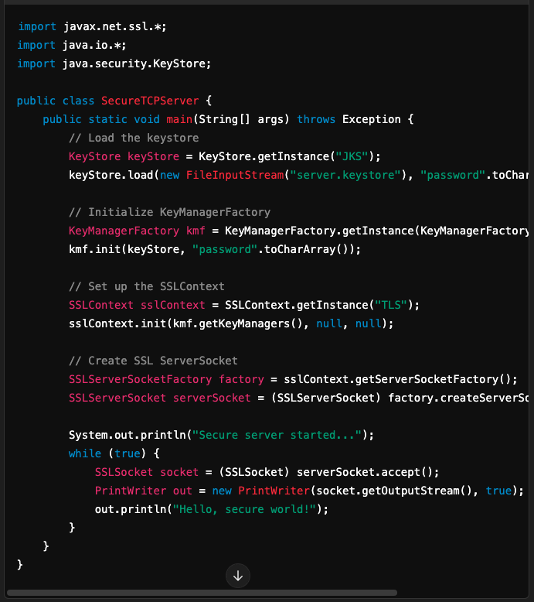

4.3 Configure the Client for SSL/TLS
- Trust the server's certificate.
- Example (Java Client):
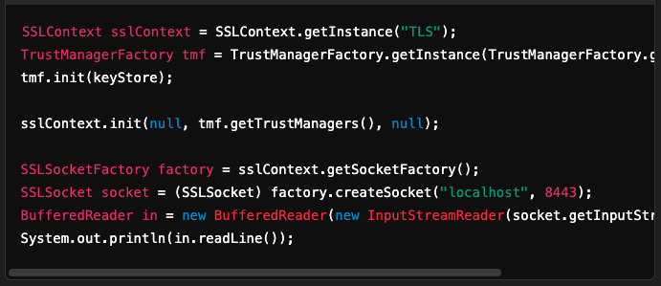

4.4 Testing the Setup
Use tools like OpenSSL or Telnet for testing:
OpenSSL:

5. Additional Considerations

5.1 Mutual TLS (mTLS)
- Both client and server authenticate each other using certificates.
- Used in high-security environments like banking systems.

5.2 Certificate Renewal
- SSL certificates have expiration dates.
- Automate renewal using tools like Certbot for Let's Encrypt.

5.3 Debugging SSL/TLS Issues
- Enable detailed logs:
- Tools like Wireshark can analyze SSL/TLS traffic.

5.4 Load Balancers
- Load balancers like NGINX or HAProxy often terminate SSL/TLS at the edge, forwarding plaintext traffic to backend servers.

6. Best Practices
- Use Strong Cipher Suites:
  - Disable weak algorithms (e.g., MD5, SHA-1).
  - Prefer AES-GCM and RSA or ECDSA for key exchange.
- Enforce Secure Protocols:
  - Disable outdated protocols like SSLv3 and TLS 1.0.
- Keep Libraries Updated:
  - Regularly update SSL/TLS libraries to patch vulnerabilities.
- Monitor Certificates:
  - Ensure certificates are valid and not expired.

SSL/TLS is the cornerstone of secure communication in modern applications. By integrating SSL/TLS into TCP applications, you can ensure data security and client-server trust.

